**Pizza Sales**

## KPIs

### Total Revenue

SELECT SUM(total_price) as Total_Revenue FROM pizzasales;

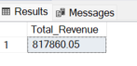

### Average Order Value

SELECT SUM(total_price) / count(distinct order_id) as AVG_Order_Value FROM pizzasales;

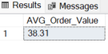

### Total Pizza Sales

SELECT sum(quantity) As Total_qty_Sold FROM pizzasales;

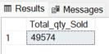

### Total Order

SELECT count(distinct order_id) as Total_Orders FROM pizzasales;

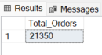

### Average number of pizza per order

SELECT cast(cast(sum(quantity) as decimal (10,2)) / cast(count(distinct order_id)as decimal (10,2)) as decimal(10,2)) as Avg_Pizza

FROM pizzasales;



### Daily Order Trend

SELECT DATENAME(DW, order_date) as order_day, COUNT(DISTINCT order_id) as total_orders

FROM pizzasales

GROUP BY DATENAME(DW, order_date);

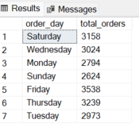

### Monthly order trend

SELECT DATENAME(Month, order_date) as month_name, COUNT(DISTINCT order_id) as total_orders

FROM pizzasales

GROUP BY DATENAME(Month, order_date)

Order by total_orders DESC;

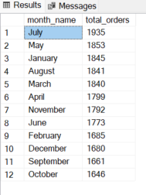

### Percentage of pizza sales

SELECT pizza_category, SUM(total_price) * 100 / (SELECT SUM(total_price) FROM pizzasales) as pct

FROM pizzasales

GROUP BY pizza_category;

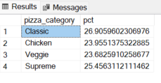

### Percentage of Sales by Size

SELECT pizza_size, Cast(SUM(total_price) * 100 / (SELECT SUM(total_price) FROM pizzasales) as decimal (10,2)) as pct

FROM pizzasales

GROUP BY pizza_size

ORDER BY pct DESC;

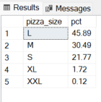

### Top 5 Best sellers by Revenue

SELECT top 5 pizza_name, sum(total_price) as total_rev

FROM pizzasales

GROUP BY pizza_name

ORDER BY total_rev DESC;

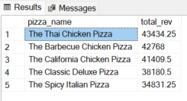

### Bottom 5 sellers by Revenue

SELECT top 5 pizza_name, CAST(sum(total_price) as decimal (10,2)) as total_rev

FROM pizzasales

GROUP BY pizza_name

ORDER BY total_rev;

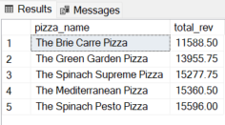

1. Top 5 Best sellers by QTY

SELECT top 5 pizza_name, sum(quantity) as total_qty

FROM pizzasales

GROUP BY pizza_name

ORDER BY total_qty DESC;

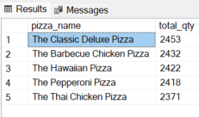

1. Bottom 5 sellers by QTY

SELECT top 5 pizza_name, sum(quantity) as total_qty

FROM pizzasales

GROUP BY pizza_name

ORDER BY total_qty ;

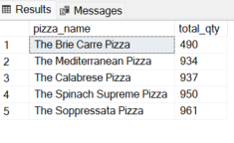

### Top 5 Best sellers by Order

SELECT top 5 pizza_name, COUNT(DISTINCT order_id) as total_order

FROM pizzasales

GROUP BY pizza_name

ORDER BY total_order DESC;

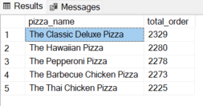

### Bottom 5 Best sellers by Order

SELECT top 5 pizza_name, COUNT(DISTINCT order_id) as total_order

FROM pizzasales

GROUP BY pizza_name

ORDER BY total_order;

